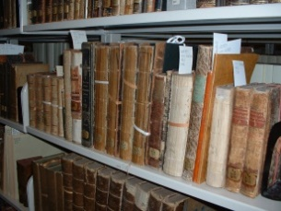
Donia Conn
Preservation Consultant for Cultural Heritage Institutions
Book and Paper Conservator
bookconservator@yahoo.com
315-396-3326
www.doniaconn.com

Connecticut League of History Organizations – StePS Program
29 August 2016

Pests:
Museum Pests
http://museumpests.net/
Insects Limited – information and store
http://www.insectslimited.com/museum
Smithsonian Institution – IPM Check List
http://www.si.edu/mci/downloads/articles/pests9.pdf
Canadian Conservation Institute - Pests
http://canada.pch.gc.ca/eng/1444922929038

Mold:
Canadian Conservation Institute – Mold
http://canada.pch.gc.ca/eng/1444920450427
CCAHA – Managing a Mold Invasion
http://www.ccaha.org/services/philadelphia-stewardship-resource-center/preservation-resources
Ellen McCrady – Mold: The Whole Picture parts 1-4
http://cool.conservation-us.org/byorg/abbey/an/an23/an23-4/an23-402.html
http://cool.conservation-us.org/byorg/abbey/an/an23/an23-5/an23-502.html
http://cool.conservation-us.org/byorg/abbey/an/an23/an23-6/an23-602.html
http://cool.conservation-us.org/byorg/abbey/an/an23/an23-7/an23-702.html
National Park Service – Leaflet 3 / 4 Mold: Prevention of Growth in Museum Collections
https://www.nps.gov/museum/publications/conserveogram/cons_toc.html
NEDCC – Moldy books and paper
http://nedcc.org/free-resources/preservation-leaflets/3.-emergency-management/3.8-emergency-salvage-of-moldy-books-and-paper

