Connecticut League of History Organizations
Executive Director Position Description
To apply: email a cover letter and resume by March 31, 2019, to interim@clho.org. “ED search” in the subject line.
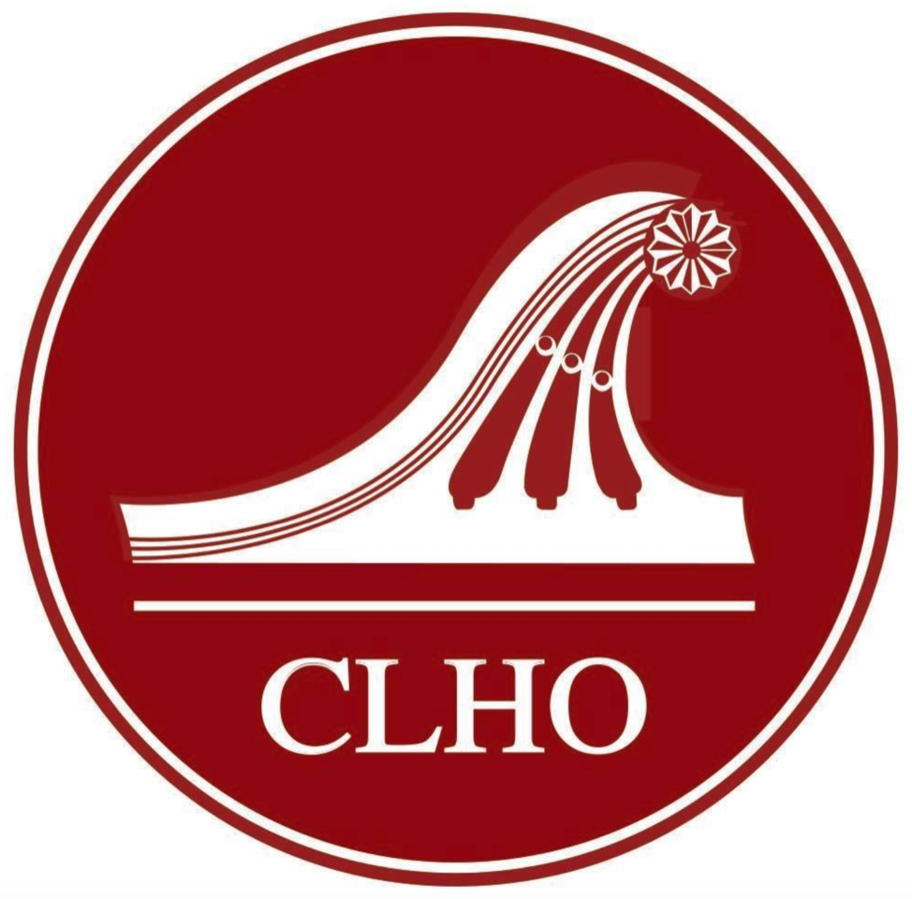

The Connecticut League of History Organizations (CLHO), with a membership base of organizations and individuals, was formed in 1948 to build connections among those who preserve and share the stories and objects of Connecticut’s past. Partnering with Connecticut Humanities (CTH) on a number of issues and programs, we are committed to building statewide capacity to preserve our state’s heritage, promote learning and engage the public.

The CLHO Executive Director serves as the chief executive of the organization, providing leadership, vision and direction in managing daily operations consistent with the mission, strategic plan and governance policies established by the Board of Directors, including priorities jointly shared by CLHO and CTH. The Executive Director is a champion, convener and catalyst for advancing CLHO’s mission to unite, support and promote historical interests and activities statewide and to strengthen and empower the network of those who promote and safeguard Connecticut’s cultural heritage.

Position Responsibilities:
- Manage strategic and operational planning, including budgets, fiscal reports, membership administration, program logistics, event registrations and other components of daily operations.
- Develop and implement a robust outreach strategy to strengthen and leverage current and new relationships with members and with regional and statewide partners, including CTH and Central Connecticut State University as well as other allied state and regional organizations.
- Provide overall program management for existing programs (Annual Conference, Awards of Merit, Connecticut Collections, StEPS-CT, workshops) and identify new program opportunities based on the CLHO-CTH partnership and on state and national trends in public history.
- Strengthen revenue streams by growing the membership base, increasing participation in programs, managing fundraising activities and identifying new grant/funder sources to achieve sustainability.
- Coordinate communications with all constituents to enhance the CLHO brand.
- Collaborate and communicate with the Board to fulfill CLHO’s mission by executing near-term strategic actions and helping formulate longer-term strategies to achieve and maintain sustainability.

Profile of the Ideal Candidate:
Skills, Experience and Attributes
- Passionate advocate for the mission with the ability to translate that passion into an articulate and compelling story for a variety of audiences.
- Visionary leader able to set strategic direction for the future while using critical and creative thinking to address near-term issues and opportunities.
- Accomplished networker, collaborator and communicator able to build and maintain strong relationships with CLHO constituents and allies and to articulate the benefits of collaboration among various individual and institutional players.
- Confident risk-taker adept at reading people and situations to help individual and institutional partners achieve beneficial outcomes.
- Time management, analytical and technological expertise to accomplish daily tasks (with QuickBooks, social media) efficiently and complement interpersonal and leadership skills.
- Sound knowledge of public history best practices; ability to organize and deliver effective professional development programs for history organizations’ staff and volunteers.

Minimum Credentials
- Bachelor’s degree in a humanities or related field. Master’s degree a plus.
- Five years experience in a leadership or management position in a public history organization.
- Valid driver’s license with ability to drive throughout the state to meet constituents.

